Mashup RT Purification Version 1.2 April 16, 2020

Contents:

- Buffer Recipes
- Gravity Flow Purification
- FPLC Purification
- Quality Control
- Typical Mashup RT Reaction
- Representative Purification Figures

- Buffer Recipes

Catabolite Repression Buffer (CRB)
25% Glycerol
25% Glucose
1 mM MgSO4
0.1 mM MnSO4
Filter sterilize, aliqout, freeze, Use 4 mL / L of media

2.5X Purification Buffer
0.75M NaCl
62.5 mM Tris-HCl pH 8.0
25% Glycerol
1.25% Triton X-100

Lysis Buffer
1X Purification Buffer
40 mM Imidizole

Wash Buffer
1X Purification Buffer
80 mM Imidizole

Elution Buffer (Gravity flow only!)
1X Purification Buffer
500mM Imidizole

Elution Buffer (FPLC only!)
1X Purification Buffer
1M Imidizole

4X Storage Buffer
600 mM NaCl
200 mM Tris-HCl pH 7.5
4 mM EDTA
0.4% IGEPAL CA-630

5X Mashup Reaction Buffer (5X MB)
125 mM Tris-HCl pH 8.3
125 mM MOPS pH 7.9
300 mM KCl
20 mM MgCl2
25% Glycerol
0.03% IGEPAL CA-630

- Gravity Flow Purification

Day 0

- Take BL21(DE3) cells transformed with Mashup-RT, either a fresh colony or a glycerol stock, and inoculate 5mL of LB with Kanamycin (50 ug/mL final conc). Let grow overnight at 37C and 275 rpm in a floor shaker.

Day 1

- Prepare LB+ by adding 4mL of filter sterilized CRB to 1L LB. Add kanamycin to 50ug/mL final concentration. Inoculate larger culture with 1mL of overnight culture for every 200 mL.

- Grow at 37C and 275 RPM until OD600 reaches 0.8-1.0. Add IPTG to final concentration of 0.5mM (1mL of 100mM IPTG per 200mL culture). Induce at 22C for 16 hours or at 16-18C for 24 hours.

Day 2

- Collect pellet by centrifugation, wash cells once with Lysis Buffer and pellet again. Discard SN and freeze pellet if stop point is required, otherwise proceed.

- Resuspend pellet with 5mL of Lysis Buffer per gram wet weight of pellet. Add protease inhibitor cocktail of choice to 1X concentration (Usually 1 tablet per 25-50 mL lysis buffer). Lysozyme is also added to a final concentration of 1mg/mL.

- Sonicate with 10 cycles of 10 seconds on, 30 seconds off. Keep lysate on ice during off period.

- Centrifuge lysate at 20,000xg for 30 minutes at 4C to pellet cell debris. Pass lysate through a 0.22um syringe filter.

- Pass lysate through a nickle bead column. For 200-500mL of initial culture volume a 0.5mL bed volume is appropriate, for 1L of culture use 1mL.

- Wash once with 10 bed volumes of Lysis Buffer, followed by 3 washes of 10 bed volumes with Wash Buffer.

- Elute with 4 bed volumes of Elution Buffer and collect flow through.

- Bring flow through up to 10mL with 1X Storage Buffer (No glycerol) and transfer to a 50kDa Cutoff spin column (we use Sartorius brand). Centrifuge until liquid level drops to 1-2mL and bring up to 10mL with fresh 1X Storage Buffer (No glycerol). Repeat for a total of 4 washes.

- After bringing down the volume for the last time, bring up to 10mL with 1X Storage Buffer (50% Glycerol) and concentrate until the volume stops going down, check every 20-30 minutes of centrifugation.

- Add freshly made DTT to a final concentration of 1mM and mix well.

- Aliquot into small portions and store at -20C. This is your concentrated stock.

- Make a series of dilutions of Mashup RT with 1X Storage Buffer (50% Glycerol), 1:1, 1:2, 1:4, 1:8, 1:16, 1:20 etc. Use these dilutions to perform RT on a reasonably abundant transcript in total RNA you have in your freezer. Something you do routinely with previously validated primers is best. Then perform PCR with primers that will produce a reasonable sized product, 1 Kb or so. Run on an agarose gel and compare against commercial RT (SS4 or equiv)

- Once the ideal working concentration of Mashup is determined, dilute a larger volume with 1X Storage Buffer (50% glycerol), aliquot and keep in the -20C freezer.

- FPLC Purification

- Perform induction, collection, lysis the same as the gravity flow purification until you have a filtered lysate. It is recommended that you start off with at least 1L of induced culture.

- Hook up a 1mL HisTrap column with your FPLC, equilibrate it with 10-20CV of 1X Lysis Buffer (40 mM Imidizole).

- Load your lysate onto the column. Wash column with 20CV of 1X Lysis Buffer (40mM Imidizole) to get rid of unbound stuff.

- Perform a segmented elution:

1)2 CV from 0-3% Elution Buffer (1M Imidizole)
2)2 CV from 3-5% Elution Buffer (1M Imidizole)
3)24 CV from 5-100% Elution Buffer (1M Imidizole), collect 0.5mL fractions

- Concentrate enzyme as described in gravity flow.

4) Quality Control

- Run samples (Lysate, pellet, flow through, first wash, second wash, eluted protein, concentrated protein) on a SDS-PAGE gel to check quality, Mashup RT is 76kDa, should be useable after using above steps. Will be of reasonable purity after a nickle column, but the 50kDa concentrator should do a good job of removing E.coli nucleases and other contaminants.

- Incubate undiluted Mashup RT as well as your working dilution with some total RNA you have in 1X MB at 37C for an hour or more. Compare to a total RNA sample without Mashup RT. You should see no difference between the two samples, indicating lack of RNase contamination.

5) Typical Mashup RT Protocol

- In a 0.2 mL tube combine:

100-500ng RNA
1uL 10uM RT Primer
1uL dNTPs
Up to 13 uL with ddH2O

- Pipette to mix and incubate at 65C for 5 minutes. Place immediately on ice for at least a minute and prepare the following mastermix:

4uL 5X MB
1uL 0.1M DTT
1uL RNase Inhibitor (Any brand, can use less)
1uL Mashup RT (Your working dilution)

- Add mastermix to RNA/primer/dNTPs, pipette to mix, place in thermal cycler/heat block.

- Incubate at 50C for 60 minutes, heat inactivate at 80C for 10 minutes.

- Freeze reaction at -20C for downstream PCR. Use between 0.1-1uL per 25uL PCR reaction.

6) Representative Gels, Figures
Here’s an old gel of gravity flow purification I found, you can get reasonable and useable purity off the concentration column.

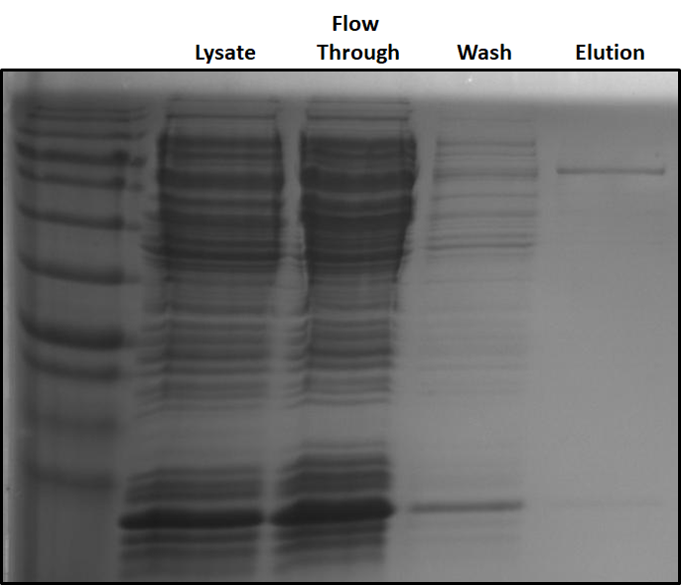

Here’s the output of our venerable FPLC, Oscar the Grouch. 1L of LB+, induced at 18C for 24 hours, purified on a 1mL HisTrap column and concentrated with a Sartorius 50kDa column.

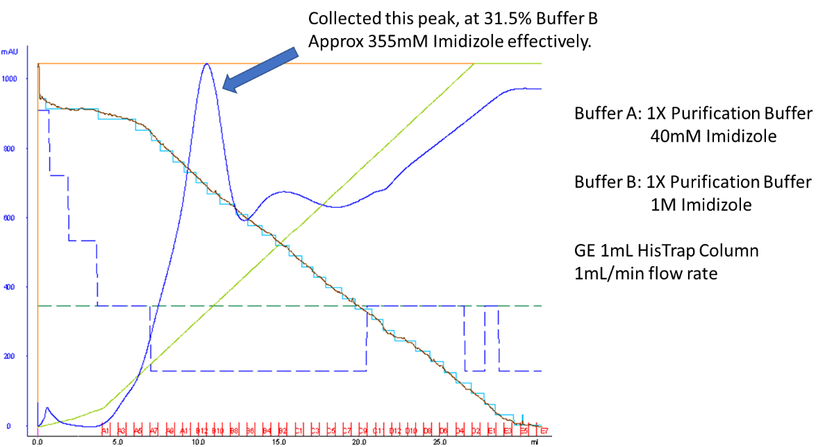
And here’s what the gel looks like:

